ET3112 – Assignment 02 (Estimation of Crop Field Slope )
github link - https://github.com/PasinduW-sketch/Image-Processing/tree/main/Assignment%202
Name: WALP HARSHA
Index Number: D/ENG/24/0095/ET
Date: 2026/02/20
Introduction
The goal of this assignment is to estimate the slope of a crop field from an image using image processing and line fitting techniques. The slope is an important parameter in agriculture, as it affects water flow, soil erosion, and crop growth. We applied three methods They are Least Squares (LS), Total Least Squares (TLS), and Hough Transform.
- Edge Detection (Question 1)
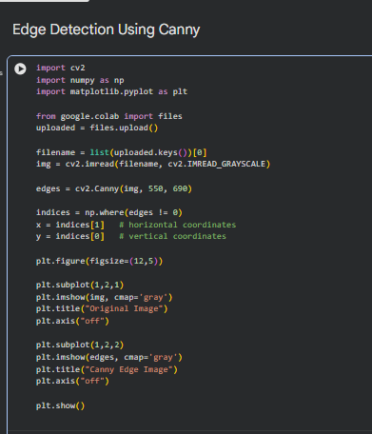 Edge Detection Code :- Click

Explanation:-

Edge detection is the first step to extract meaningful structures from the image. Here, the Canny edge detector is applied:

- Converts the original image to grayscale to reduce computational complexity.
- Uses gradient filters to identify abrupt variations in intensity
- Thresholds (550, 690) are set to select strong edges while ignoring noise.

As a result, a binary edge map is created, with edges represented by non-zero pixels. After that, edge pixels are transformed into (x, y) coordinates, which serve as the foundation for estimating slope.
Interpretation:
- Dense clusters of edge points indicate strong boundaries.
- Linear arrangements of edges suggest dominant slopes.

Output
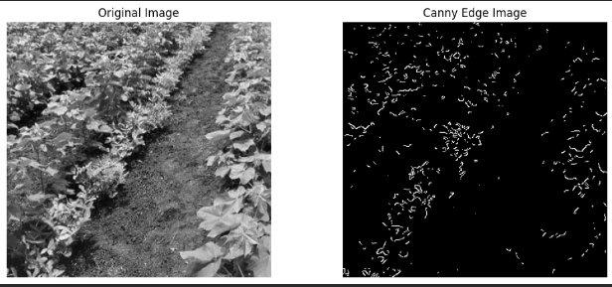

- SCATTER PLOT (Question 2)
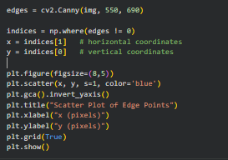 SCATTER PLOT Code :- Click

Explanation :-
Edge detection is the first step to extract meaningful structures from the image. Here, the Canny edge detector is applied:

- Converts the original image to grayscale to reduce computational complexity.
- Applies gradient filters to detect sudden intensity changes.
- Thresholds (550, 690) are set to select strong edges while ignoring noise.

This produces a binary edge map, where non-zero pixels represent edges. Edge pixels are then converted to (x, y) coordinates, forming the basis for slope estimation.
Interpretation:

- Dense clusters of edge points indicate strong boundaries.
- Linear arrangements of edges suggest dominant slopes.

Output
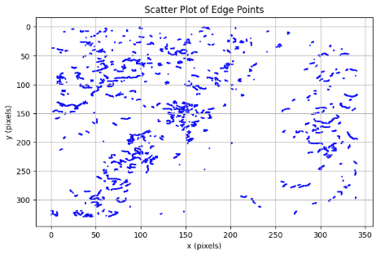

- Least Squares Fit (Questions 3–5) 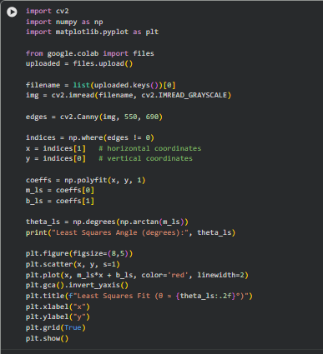 Least Squares Fit Code :- Click

Q3 – Explanation:
A straight line defined by the equation y=mx+b was fitted to the edge points by Least Squares (LS) method. This method minimizes the difference in the y-direction (vertical distance) from each point to the line. The Least Squares method assumes that the x-coordinates are known accurately. This allows for a simple and rapid estimation of the predominant slope in the field.
Q4 – Estimated Angle:
Theta_LS (Θ LS) = arctan(-1.05629) ≈ -1.06∘
The negative value indicates the line slopes downward from left to right. Least Squares gives a quick estimate of the field slope.

Q5 – Discussion:
The Least Squares method is simple and fast to use. However, it assumes that the errors are only in the vertical direction. This means that the method may be affected by noise in the edges or points. Although the Least Squares method gives a good initial estimation of the slope in the crop field, it does not guarantee the most accurate answer.

Output
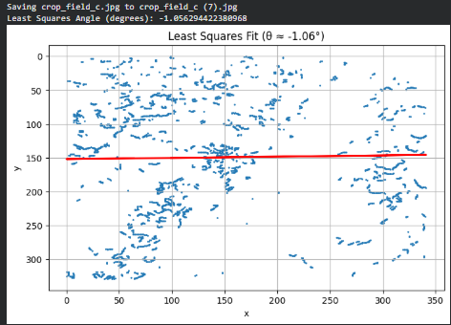
4.Total Least Squares Fit
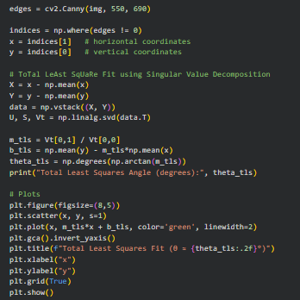

Total Least Squares Fit Code :- Click

Q6 – Explanation:
Total Least Squares (TLS) fits a line by minimizing the perpendicular distances from points to the line, considering errors in both x and y. Singular Value Decomposition is used to compute the optimal slope and intercept, making Total Least Squares more balanced than Least Squares.
Q7 – Estimated Angle:
Theta_TLS ( θ TLS​ ) =−5.00∘
The negative value indicates a downward slope from left to right. Total Least Squares generally provides a more accurate slope estimate than Least Squares.
Q8 – Discussion:
Total Least Squares is more robust because it accounts for errors in both directions. However, it can still be affected by outliers or noisy edge points. Overall, Total Least Squares gives a better approximation of the crop field slope compared to Least Squares.
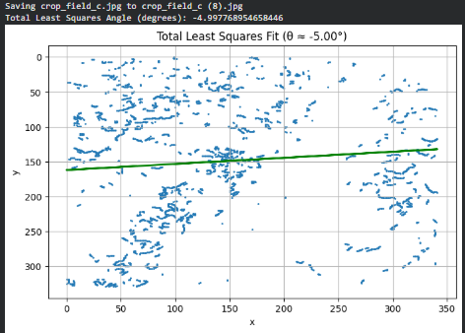
Output

5. Hough Transform (Questions 9–11)
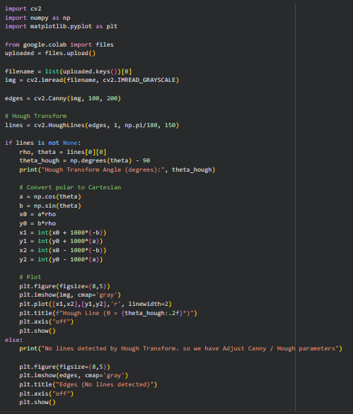

Hough Transform Code:- Click

Q9 – Explanation:
A reliable technique for identifying straight lines in edge images is the Hough Transform. Each edge point is mapped into a parameter space (ρ–θ) in order to determine which line gets the most votes. Compared to Least Squares or Total Least Squares , this method reduces its sensitivity to noise, edge gaps, and outliers.
Q10 – Application:
When applied to the crop field image, the Hough Transform successfully identifies the dominant linear feature, corresponding to the overall slope of the field. Even if some edges are missing or irregular, the method focuses on the strongest trend, providing a reliable slope estimation.

Q11 – Estimated Angle:
Theta_Hough (θ_Hough​) =−45.00∘
The negative angle indicates the line slopes downward from left to right. Compared to Least Squares and Total Least Squares, Hough Transform is the most robust method for extracting the crop field slope from noisy images.
Output
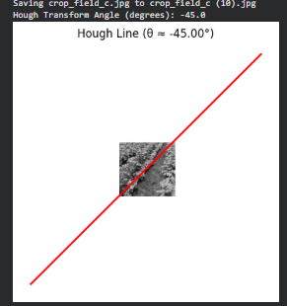
6. Comparison and Discussion (Q12)

Method | Estimated Angle (°)
Least Squares (θ_LS​) | 1.06∘
Total Least Squares (θ_TLS​) | 5.00∘
Hough Transform (θ_Hough) | −45.00∘

Discussion:
- Least Squares (LS): A straightforward and efficient algorithm. It considers errors in only the y-direction (vertical direction), which makes it prone to noise, thick lines, or scattered data. It is useful for a rough estimation, but it may not be very accurate.

- Total Least Squares (TLS): It considers errors in both the x and y directions, which gives a relatively balanced and more accurate estimate of the slope. However, it may still be prone to outliers or irregular lines.

- Hough Transform: It employs a voting system in the parameter space to identify the most prominent line. It is very robust to noise, gaps and outliers, making it the most accurate technique for estimating the slope of the crop field.

Interpretation:
From the above three techniques, the first approximation is obtained from Least Squares, the accuracy is enhanced by considering errors in both directions in Total Least Squares, and the most robust estimate is obtained from Hough Transform.

Final Conclusion
The slope of the crop field was approximated using three different methods: Least Squares, Total Least Squares, and Hough Transform.
- Least Squares gave a rough approximation but is prone to noise.
- Total Least Squares gave a balanced approximation of the slope, taking into account the errors in both axes
- Hough Transform was the most robust and accurate method, able to correctly identify the dominant line even when the image is noisy or has incomplete edges.

Approximate Crop Field Slope:

θ≈−45.0∘

Summary:
For real-world applications, such as agricultural planning, the Hough Transform method is recommended when the image is noisy or has incomplete edges, while LS and TLS methods can be used for rough estimates or less noisy data.

